**Basic Assignment 1**

1.Q: Armstrong number

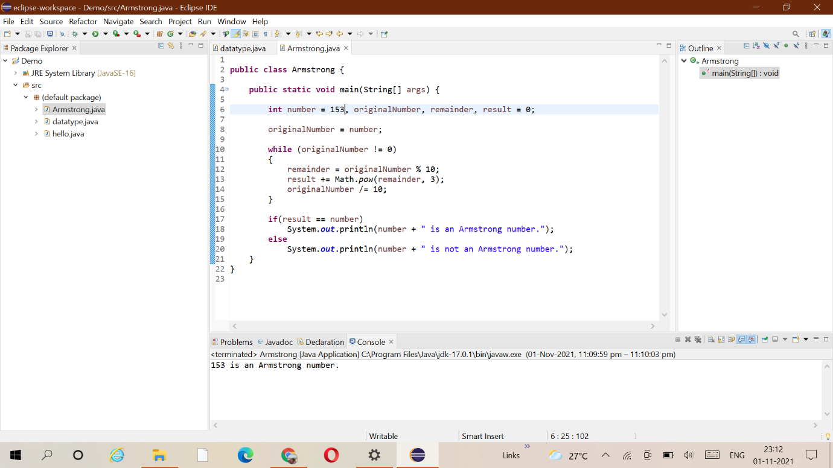

2.Q: Armstrong number falling in the range of 100-999

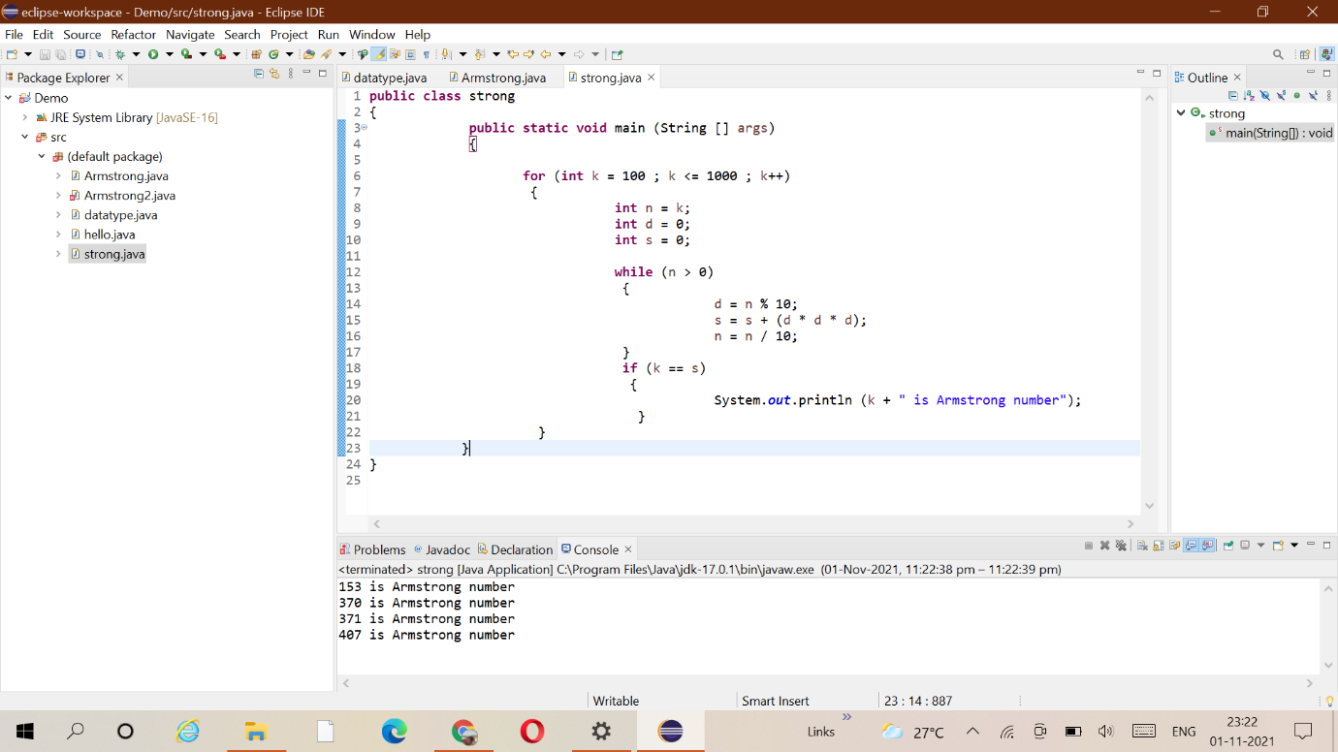

3.Q: Simple compound interest

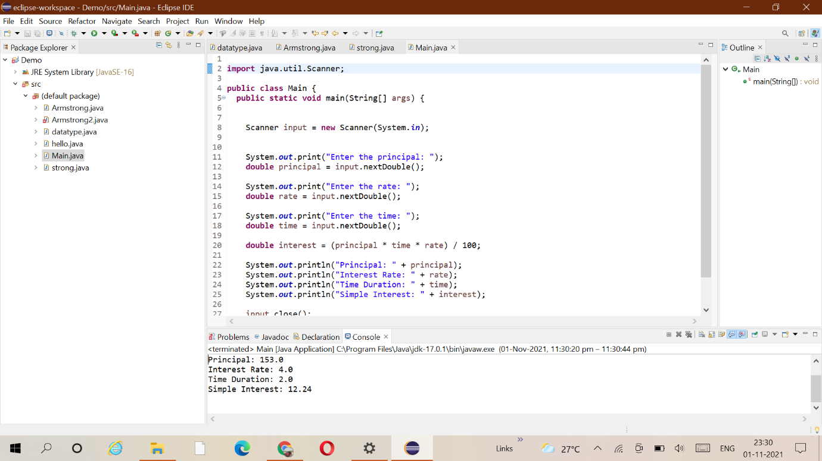

4.Q: Subject Marks

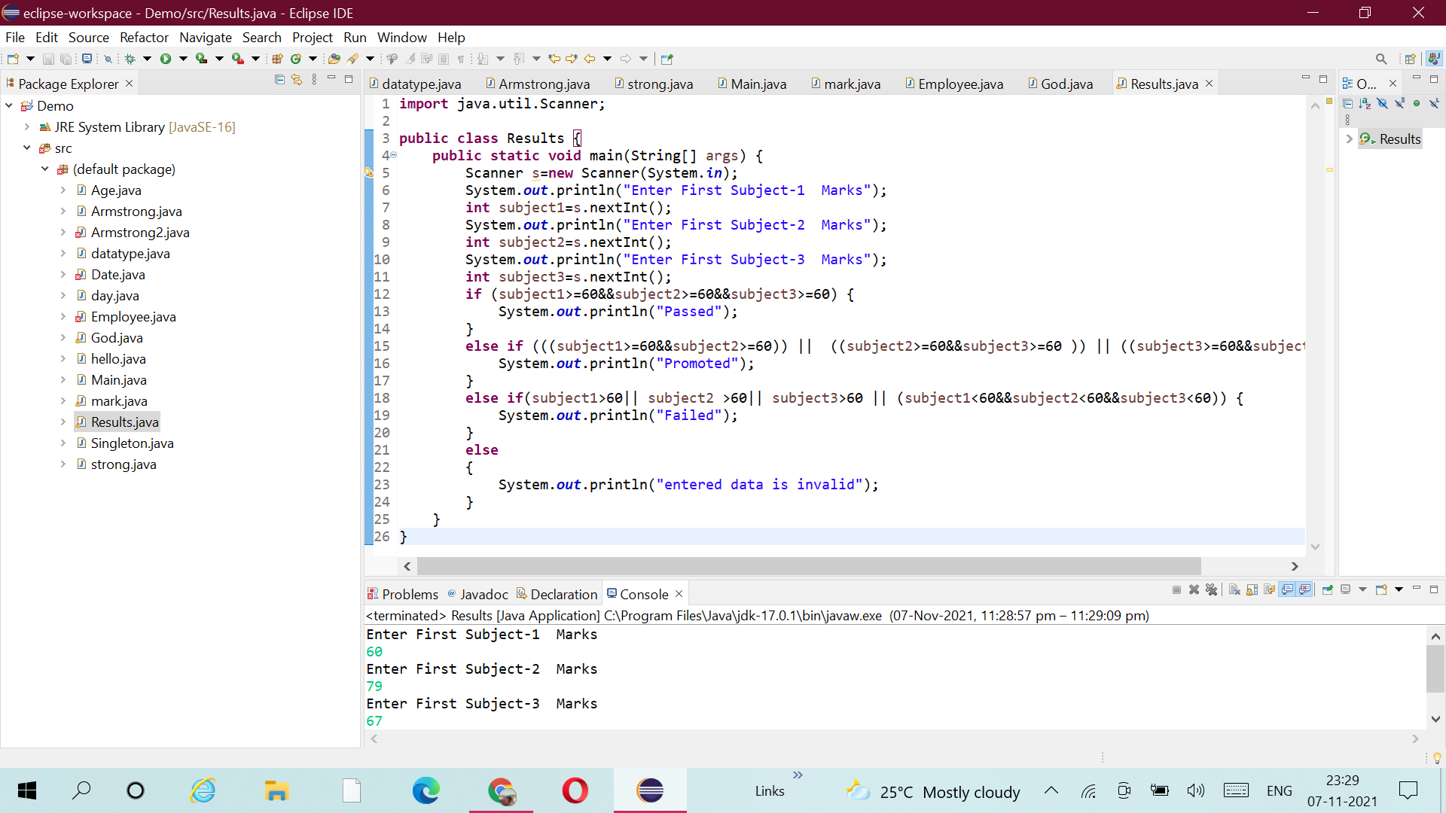

5.Q: Income Tax

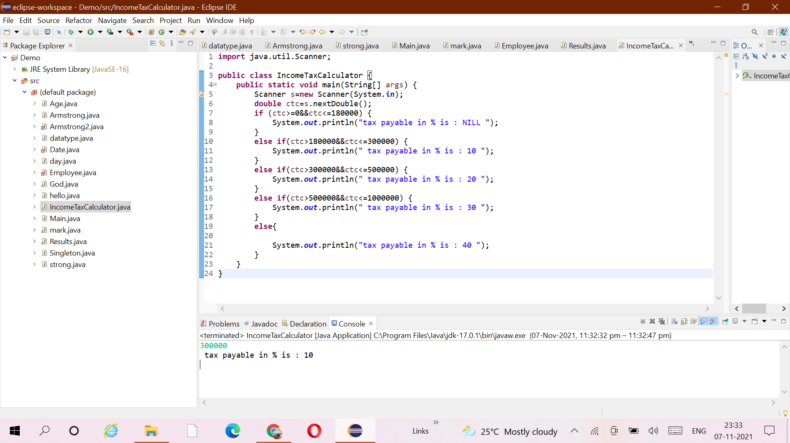

8.Bubble Sort

